
Semester 2 Examination 2016

Question/Answer booklet

Year 12
MATHEMATICS SPECIALIST

ANSWERS

Book 1 of 2
Section One
(Calculator-free)

Circle teacher’s name Mr Hill Mr Lau

Time allowed for this section
Reading time before commencing work: 5 minutes
Working time for section: 50 minutes

Material required/recommended for this section

To be provided by the supervisor
This Question/Answer booklet for Section One, and a separate formula sheet which may also be used for Section Two.

To be provided by the candidate
Standard items: pens, pencils, pencil sharpener, highlighter, eraser, ruler

Important note to candidates
No other items may be taken into the examination room. It is your responsibility to ensure that you do not have any unauthorised notes or other items of a non-personal nature in the examination room. If you have any unauthorised material with you, hand it to the supervisor before reading any further.

Structure of this examination

 | Number of questions available | Number of questions to be attempted | Working time (minutes) | Marks available | Percentage of Exam
Section One  Calculator—free | 8 | 8 | 50 | 53 | 35%
Section Two  Calculator—assumed | 13 | 13 | 100 | 99 | 65%
Total marks |  |  |  | 152 | 100%

Instructions to candidates

1. Answer all the questions in the spaces provided.

2. Spare answer pages are provided at the end of this booklet. If you need to use them, indicate in the original answer space where the answer is continued i.e. give the page number.

3. Show all your working clearly. Your working should be in sufficient detail to allow your answers to be checked readily and for marks to be awarded for reasoning. Correct answers given without supporting reasoning may not be allocated full marks. Incorrect answers given without supporting reasoning cannot be allocated any marks. If you repeat an answer to any question, ensure that you cancel the answers you do not wish to have marked.
4. It is recommended that you do not use pencil except in diagrams.

Question 1 (5 marks)

(a) Evaluate (2 – i)(1 – 2i), leaving your answer in polar form. (2 marks)


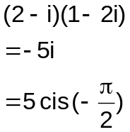
Multiplies out correctly

Converts to polar form

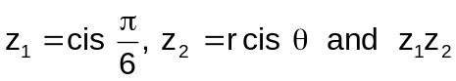
(b) If is a real number, determine the value(s) of θ
where -π < θ ≤ π. (3 marks)

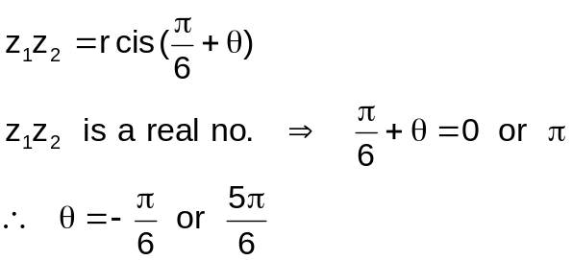
Determines the argument for z₁z₂

Equates the argument = 0 or π

States the answers

Question 2 (7 marks)

(a) Two random samples of 9 students from Year 12 Hale School are taken. The following table shows their brief summary of statistics of their heights.
 | Mean (cm) | Standard deviation (cm)
Sample 1 | 177.5 | 10.5
Sample 2 | 179.2 | 9.4

Briefly explain why the two sample means are expected to be different. (2 marks)

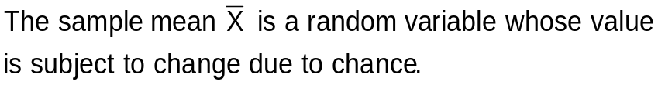

Explains that ‾X is a random variable

States that the value of ‾X changes due to chance

(b) The sampling distribution of the heights of random samples of 9 students from Year 12 Hale School has a mean of 178.4 cm and a standard deviation of 8.2 cm.

(i) Find the mean and standard deviation of all Year 12 Hale students' height.
(3 marks)
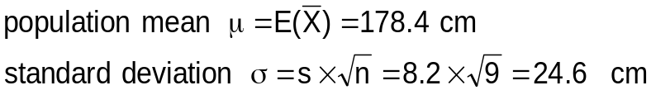

States the population mean

Uses the correct formula for calculating σ

States the population standard deviation

(ii) Is it valid to assume that the sampling distribution of the heights is approximately normal? Explain. (2 marks)

States not valid

Provides a valid explanation

Question 3 (5 marks)

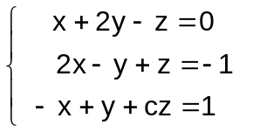

(a) Determine the value of c if the three equations have no
solutions. (4 marks)

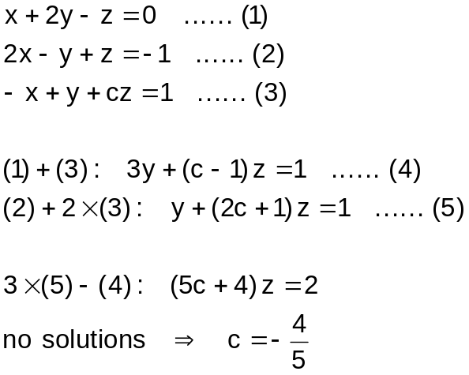
Eliminates one variable

Eliminates another variable

Sets the coefficient of the remaining variable to zero

States the answer

(b) Given the answer in (a), give a geometric interpretation of the three planes in (a).
(1 mark)

States parallel intersection lines

Question 4 (6 marks)
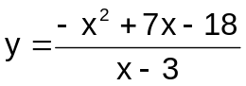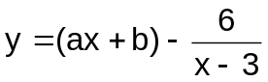
(a) Simplify the function to the form . (2 marks)

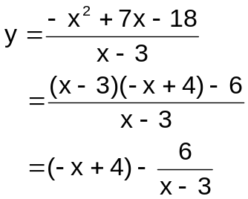
Shows the correct value of a

Shows the correct value of b

(b) Hence sketch the graph of the function . (4 marks)

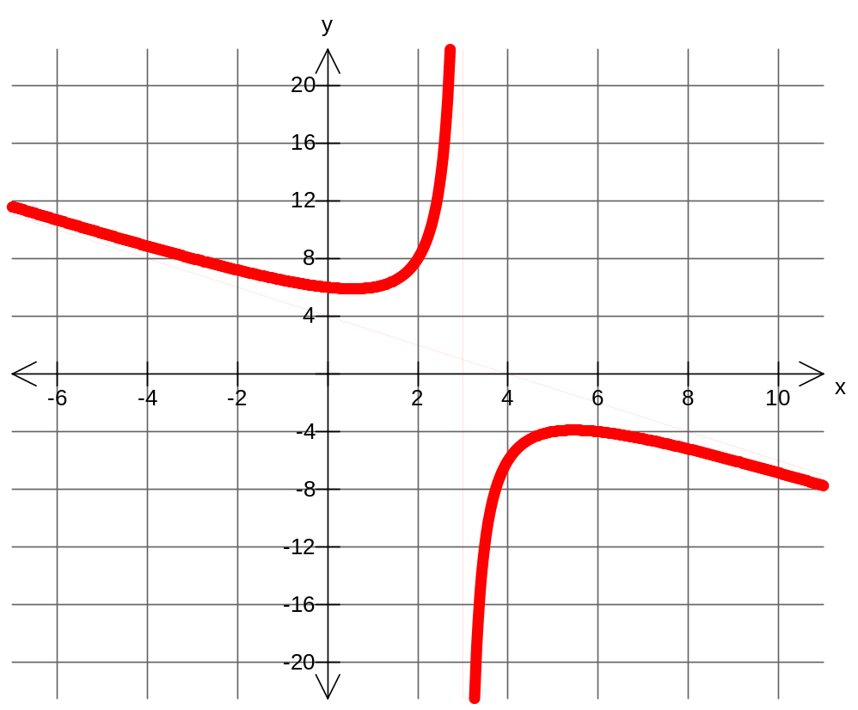

Shows the correct graph shape as x → ±∞ (sloping asymptote)

Shows the correct shape as x → 3
(vertical asymptote)

Shows the correct y-intercept

Shows a local min and a local max

Question 5 (8 marks)
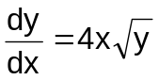
(a) Solve if y = 1 when x = -1. (4 marks)

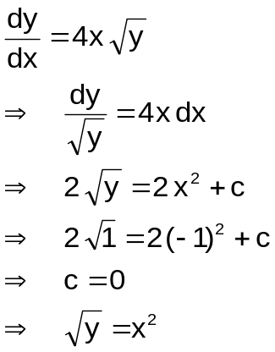
Separates the variables

Integrates correctly

Uses (1, -1) to solve for c

States the answers

(b) Sketch the slope fields of for the 6 points indicated below. (4 marks)

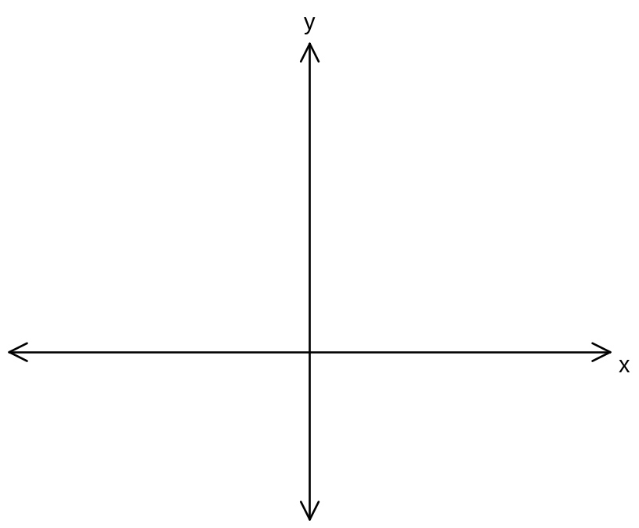

Shows horizontal lines at x = 0

Shows horizontal lines at y = 0

Shows positive slope at (1, 1)

Shows negative slope at (-1, 1)

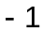

Question 6 (11 marks)

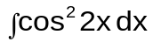Find the following integrals.

(a) (3 marks)

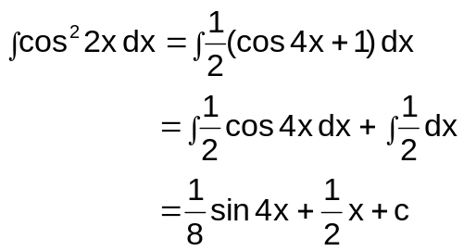
Uses the correct trig identity

Integrates cos 4x correctly

States the correct answer, including the constant c

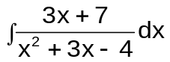
(b) (3 marks)

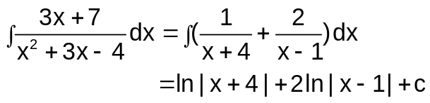
Uses partial fractions

Obtains correct numerators

States the answer

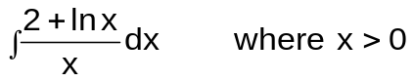(c) (2 marks)

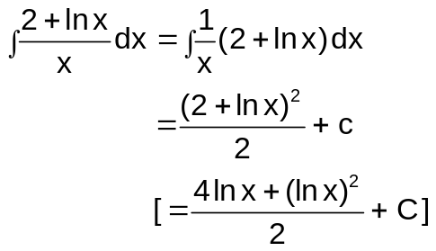
Recognizes that the integral is of the form ∫ f '(x) f(x) dx

Integrates correctly

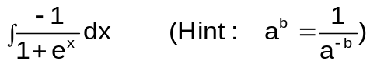
(d) (3 marks)

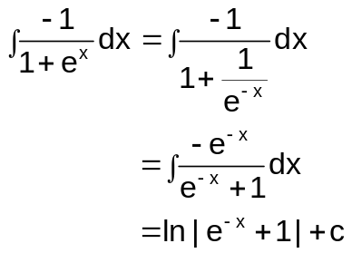
Writes e^{x} as 1/e^{-x}

Writes the integrand in the form f '(x)/f(x)

States the answer

Question 7 (5 marks)

(a) Give a geometric interpretation of the magnitude of a×b regarding the parallelogram spanned by the vectors a and b. (1 mark)

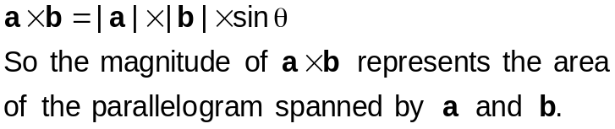
Gives the correct interpretation

(b) Consider 3 points A, B and C with corresponding position vectors a, b and c in space as shown below. The points O, A, B and C form a tetrahedron.
x
y
z
A
B
C
O
b
a
c
(i) Express AB and AC in terms of a, b and/or c. (1 mark)

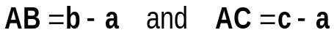

States the answers

(ii) The area vector of a face is a vector perpendicular to
the face, pointing outwards, whose magnitude is the
area of the face.
Show that the sum of the outward pointing area vectors
of the 4 faces of the tetrahedron equals the
zero vector.

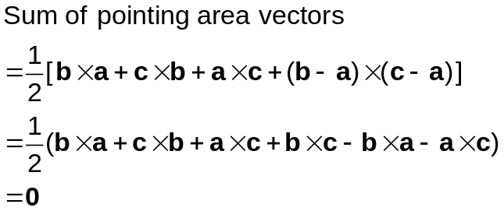
(3 marks)

Writes down the area any face using the correct cross product

Multiplies out correctly

Shows that the sum equals the zero vector

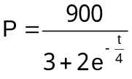Question 8 (6 marks)

A model for a population, P, of numbats is , where t is the time in years from the start of 2015.

(a) What is the initial population? (1 mark)
States the answer
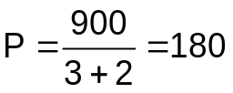

(b) What is the predicted long term population? (1 mark)
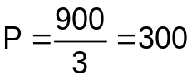
States the answer

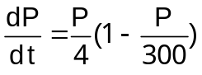
(c) Show clearly that P satisfies the differential equation . (4 marks)

Expresses e^{-t/4} in terms of P

Differentiates to get dP/dt

Uses e^{-t/4} in terms of P to express dP/dt in terms of P

Simplifies correctly
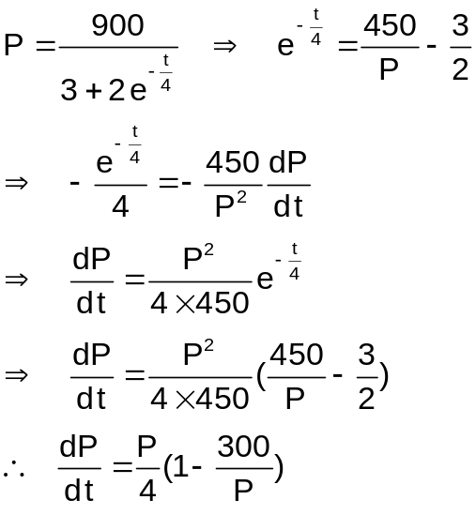

Additional working space

Question number(s): ________________

Semester 2 Examination 2016

Question/Answer booklet

Year 12
MATHEMATICS SPECIALIST
Answers
Book 2 of 2
Section Two
(Calculator-assumed)

Circle teacher’s name Mr Hill Mr Lau

Time allowed for this section
Reading time before commencing work: 10 minutes
Working time for section: 100 minutes

Material required/recommended for this section

To be provided by the supervisor
This Question/Answer booklet for Section Two. Candidates may use the separate formula sheet from Section One.

To be provided by the candidate
Standard items: pens, pencils, pencil sharpener, highlighter, eraser, ruler
Special items: drawing instruments, templates, notes on up to two unfolded sheets of A4 paper, and up to three calculators, approved for use in this examination.

Important note to candidates
No other items may be taken into the examination room. It is your responsibility to ensure that you do not have any unauthorised notes or other items of a non-personal nature in the examination room. If you have any unauthorised material with you, hand it to the supervisor before reading any further.

Structure of this examination

 | Number of questions available | Number of questions to be attempted | Working time (minutes) | Marks available | Percentage of Exam
Section One  Calculator—free | 8 | 8 | 50 | 53 | 35
Section Two  Calculator—assumed | 13 | 13 | 100 | 99 | 65
Total marks |  |  |  | 152 | 100

Instructions to candidates

1. Answer all the questions in the spaces provided.

2. Spare answer pages are provided at the end of this booklet. If you need to use them, indicate in the original answer space where the answer is continued i.e. give the page number.

3. Show all your working clearly. Your working should be in sufficient detail to allow your answers to be checked readily and for marks to be awarded for reasoning. Correct answers given without supporting reasoning may not be allocated full marks. Incorrect answers given without supporting reasoning cannot be allocated any marks. If you repeat an answer to any question, ensure that you cancel the answers you do not wish to have marked.
4. It is recommended that you do not use pencil except in diagrams.

Question 9 (6 marks)

Suppose that the heights of students at Hale School follow a normal distribution. It is found that a large random sample of Hale students has a mean of 172 cm with a 6 cm margin of error at a confidence level of 90%.

(a) Write down the confidence interval for estimating the mean height of Hale School students. Interpret your answer. (2 marks)

Confidence interval: [166, 178]

We are 90% confident that the interval [166, 178] contains the true mean height of Hale students.

Or About 90% of repeated random samples will contain the true mean height of Hale students.

Gives the correct interval

Provides a valid interpretation
States the CI decreases

Provides a valid interpretation
States the CI increases

Provides a valid interpretation

(b) What would be the change in the confidence interval (increase, decrease or no change) if the sample size increases? Explain. (2 marks)
Confidence interval decreases

Randomness of the data is smoothened off with a larger sample size, so margin of error decreases and hence confidence interval decreases.

(c) What would be the change in the confidence interval if the confidence level is set at 95% instead of 90%? Explain. (2 marks)
Confidence interval increases

At 95% confidence level, the margin of error would increase.
Hence the confidence interval increases.

Question 10 (7 marks)
Consider the functions f(x) = ln (5e – x) and g(x) = e^{x} + 4e.

(a) Give an example of x such that f( g(x) ) is not defined. (1 mark)

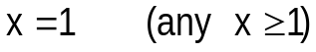
States the answer

(b) (i) State the largest restricted domain of g(x) such that f( g(x) ) is a function.
(2 marks)

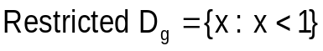
Gives the correct upper bound

Uses the correct inequality sign

Consider the restricted domain of g(x) in part (b) (i).

(ii) Show that f( g(x) ) is a one-to-one function. (4 marks)

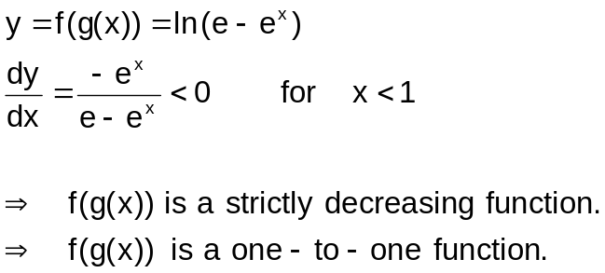
Shows the correct composite function

Differentiates correctly

Shows that dy/dx is less than 0

Provides a reason for 1-1 function

OR
Shows the correct composite function

Equates f(g(y))=f(g(x)

With reasons establishes x=y

Provides a reason for 1-1 function
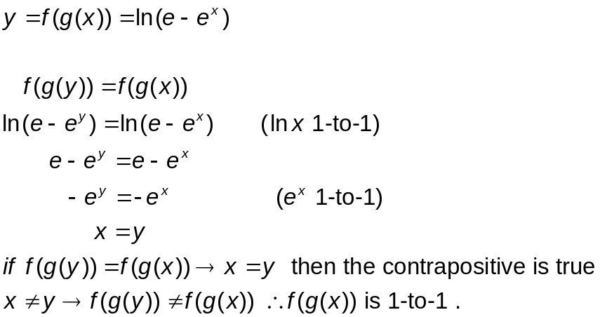

Question 11 (8 marks)

Random samples of size 36 are drawn from a large population of ball bearings.
A particular sample has a mean of 22.40 g, with a standard deviation of 0.72 g.

(a) Estimate the standard deviation of the sampling distribution of the mean. (2 marks)
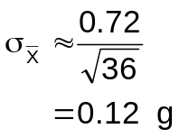
Uses the correct formula

States the answer

Consider a 96% confidence interval for the population mean.

(b) State the values (correct to 4 decimal places) of the standard normal variable corresponding to 96% confidence interval. (1 mark)
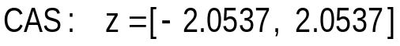
States the answer

(c) Determine the 96% confidence interval for the population mean. (2 marks)

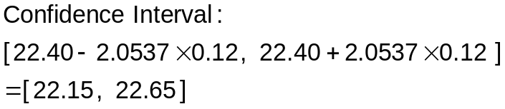
Uses the correct interval formula

States the answer

(d) Assume that the population standard deviation of ball bearings can be estimated by 0.72 g, determine how large a sample must be taken in order to be 96% confident that the error in the estimation of population mean will not exceed 0.15 g. (3 marks)

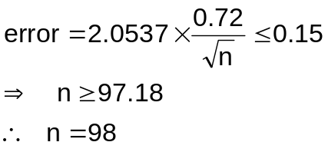
Uses the correct error formula

Solves the inequality correctly

States the answer

Question 12 (8 marks)

Laura is travelling on a Ferris wheel of radius 40 metres, that is turning at a constant angular speed of one revolution every 5 minutes. Initially, Laura’s cabin is at ground level, at point S. The sun is directly overhead and casts a shadow on the ground directly below Laura’s cabin.
S
1 revolution every 5 min
●

θ
x
cabin
40 m

shadow

Let θ be the angle that the radius joining the centre of the Ferris wheel to the cabin
makes with the downward vertical, and
x be the horizontal displacement of the shadow from the point S on the ground.

(a) Express θ in terms of time t (in min). (2 marks)

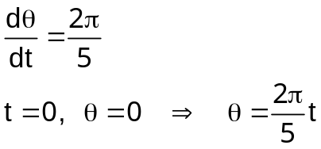
Determines dθ/dt

States the answer

(b) Show that the shadow moves with simple harmonic motion. (3 marks)

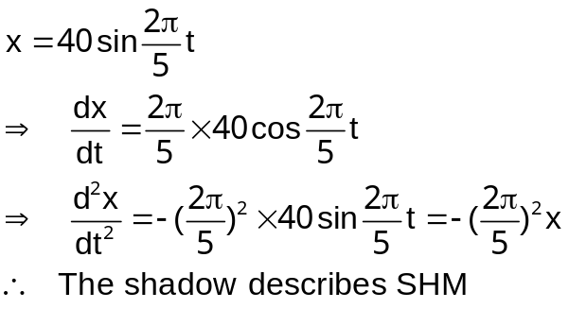
Determines the displacement equation

Differentiates x twice to obtain the acceleration

Identifies the SHM eq

(c) Find the exact speed at which the shadow is moving horizontally, when the cabin is 20 m above the ground. (3 marks)

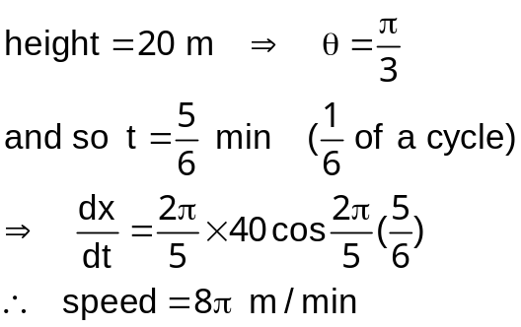
Determines θ for h = 20 m

Determines the corresponding time

Uses the velocity equation to determine the speed

Question 13 (9 marks)

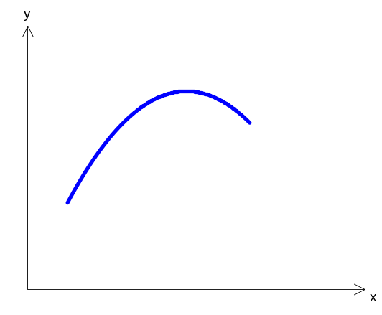
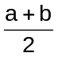
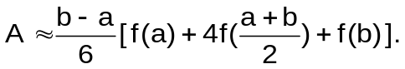The area A under the graph of y = f(x) from x = a to x = b can be approximated by

The above method is used to estimate the area under
the graph of y = x ln x from x = 2 to x = 3.
a
b
y = f(x)
Use 4 strips to approximate the area and give your answers
correct to 4 decimal places for parts (a) and (b), if necessary.

x | 2 | 2.25 | 2.5 | 2.75 | 3
f(x) | 1.3863 | 1.8246 | 2.2907 | 2.7819 | 3.2958

(a) Complete the following table. (2 marks)

Shows correct x values

Evaluates y values

(b) Show clearly how you use the above formula to obtain an estimate of the required area. (4 marks)

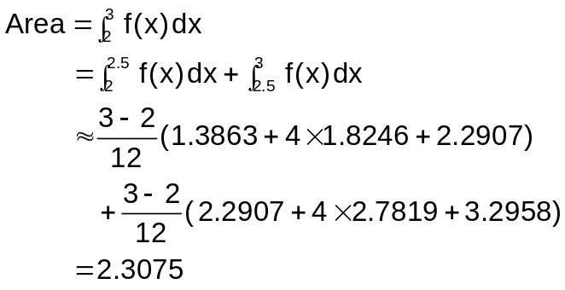
Expresses the area as the sum of two areas with correct boundaries

Calculates width correctly

Uses the given formula correctly

States the answer

(c) State an approximation of the area correct to 6 decimal places. Provide evidence for your estimation. (2 marks)

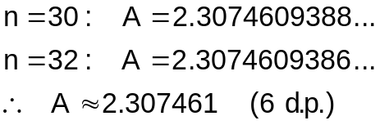
Provides an evidence

States the answer

(d) State the type of function f(x) such that the formula
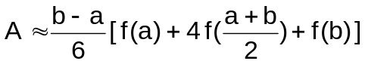

actually gives an exact answer. (1 mark)

States the answer

Question 14 (6 marks)

Let z = x + yi be a complex number where x and y are real numbers.
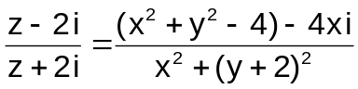
(a) Show that . (2 marks)

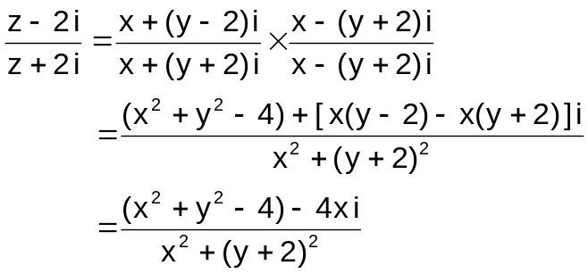
Realises the expression

Simplifies correctly

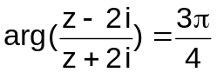
(b) Sketch the locus of z such that . (4 marks)
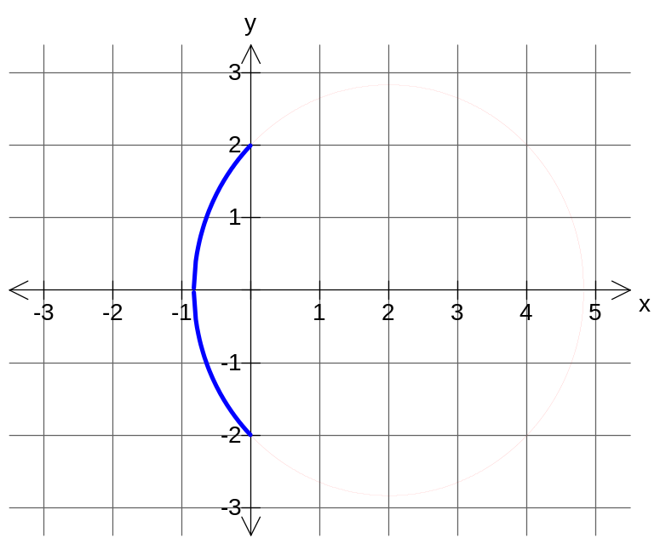

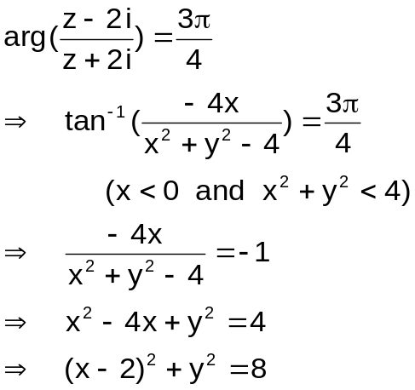

Writes the argument in terms of x and y

Sets up the algebraic equation

Simplifies to get the circle equation

Shows the correct arc

Question 15 (7 marks)

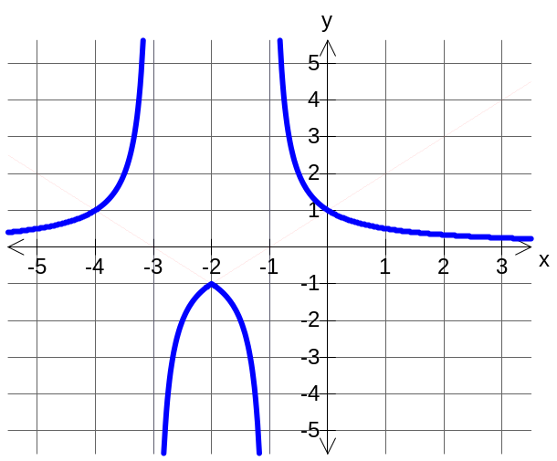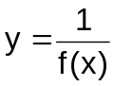(a) Given the graph of the function y = f(x) as shown below, sketch the graph of its
reciprocal function . (3 marks)

Shows vertical asymptotes at -3 and 1

Passes through (-2, -1)

Shows a reasonable shape

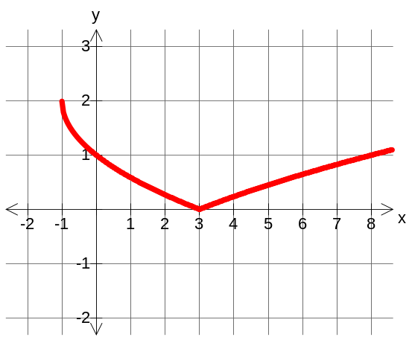(b) Determine the function y = g(x), where g(x) is a square-root function, such that the graph of y = | g(x) | is as shown below. (2 marks)

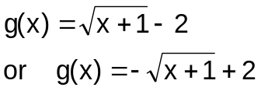

Gives the correct horizontal translation of g(x)

Gives the correct vertical translation of f(x)

(c) Determine the function y = h(x), where h(x) is a reciprocal function, such that the graph of y = h( |x| ) is as shown below. (2 marks)
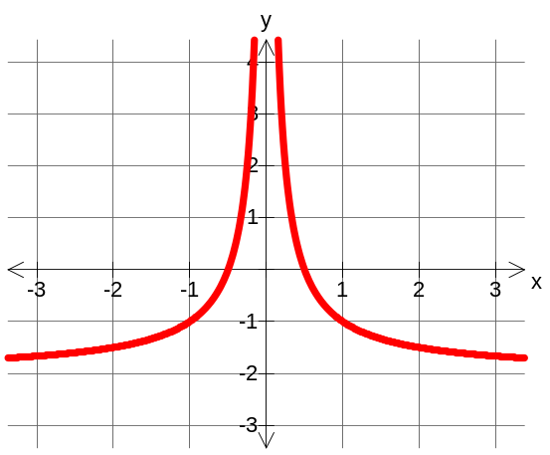

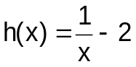

Gives the term 1/x

Gives the correct vertical translation of h(x)

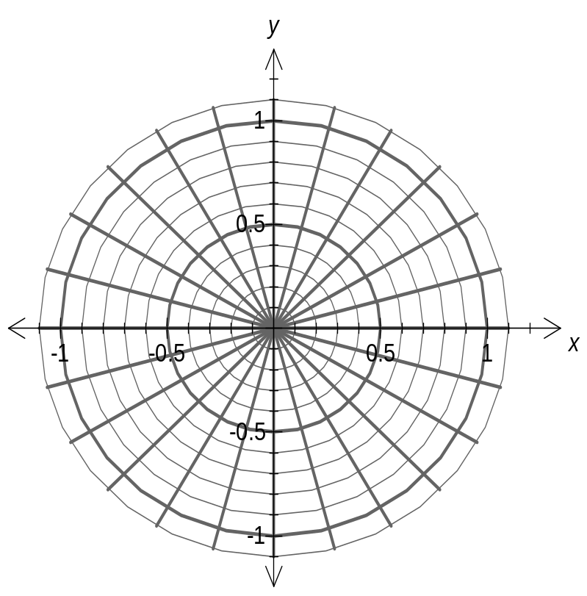
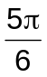
Question 16 (7 marks)

A complex number z⁵ is shown on the right.
z²

(a) Express z⁵ in polar form. (1 mark)
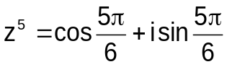
z⁵

States the answer

z¹⁰

(b) On the above set of axes, plot the following complex numbers. Label them clearly.
(3 marks)

(i) z²
Shows correct modulus

Shows correct arguments

(ii) z¹⁰

(c) Determine n such that z⁵ = z^{n} where n (≠ 5) is a positive integer. (3 marks)

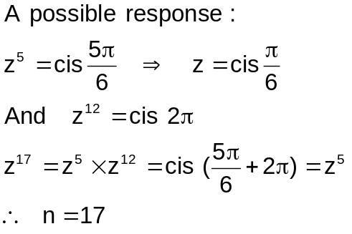
Solves for z

Shows z¹² represents a complete revolution

Multiplies z⁵ and z¹² to get z⁵ and hence states the answer

Question 17 (9 marks)

A line l passes through the z-axis at z = 2 and is parallel to the y-axis.

(a) State the vector equation of l. (2 marks)
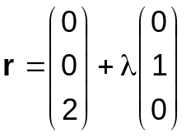
Shows that l passes through (0, 0, 2)

Shows that l 's direction is parallel to (0, k , 0)

(b) Find the vector equation of the plane π that contains l and passes through
(1, 0, 0). (3 marks)
Indicates that π is ⊥ to both (1, 0, -2) and (0, 1, 0)

Uses cross product to find n

States the answer
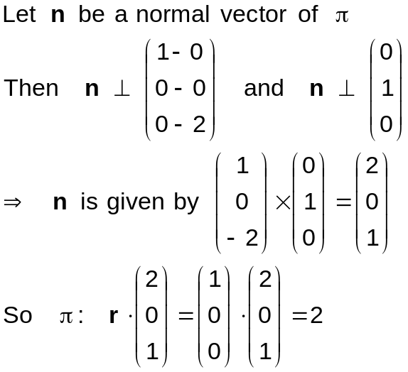

(c) The plane π in part (b) touches a sphere whose centre is at (0, 0, 0). Find the Cartesian equation of the sphere. (4 marks)
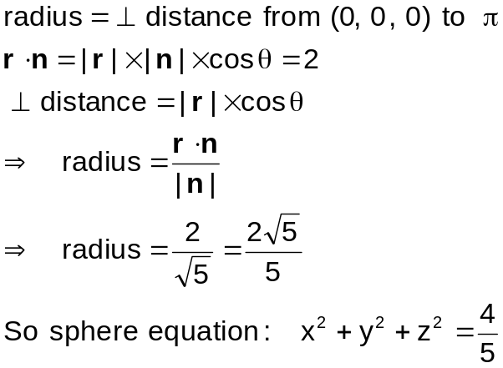
Shows radius = ⊥ distance

Uses r cos θ as ⊥ distance

Determines the radius

States eqn of sphere

Question 18 (10 marks)

The position of a particle P is defined by the vector function

where b > 0 and 0 ≤ t ≤ π.

(a) Determine the Cartesian equation corresponding to the vector equation. (3 marks)

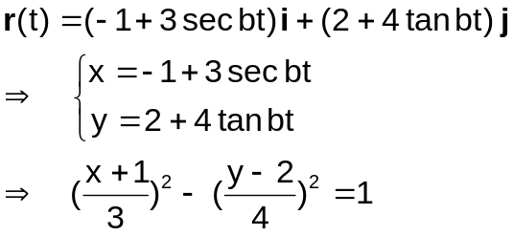
Equates corresponding components

Uses sec²x = tan²x + 1

States the answer

(b) Find the velocity vector of the particle P at time t. (1 mark)

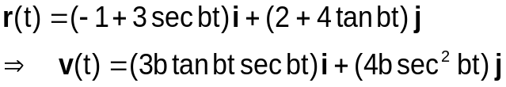
Differentiates r(t) correctly

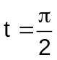
(c) Particle P is moving vertically when . Determine the minimum value of b.
(3 marks)

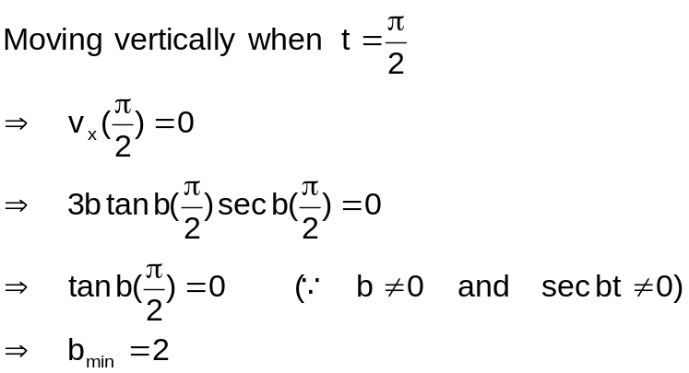
Sets v_{x}(π/2) = 0

Sets tan b(π/2) = 0 with reasons

States the answer

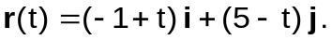A second particle Q starts at the same instant as P and moves with position vector
given by

(d) Assuming the minimum value of b in part (c), determine whether P and Q collide or their paths cross. State the time when the incident happens. (3 marks)

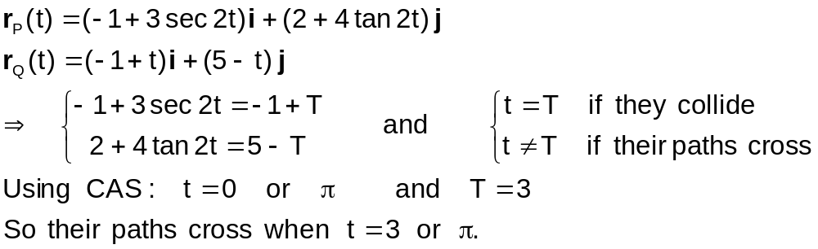

Equates corresponding components

Solves correctly for the times

States their paths cross when t = 3
(or t = π)

Question 19 (9 marks)
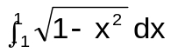
(a) By considering the geometric interpretation of explain why
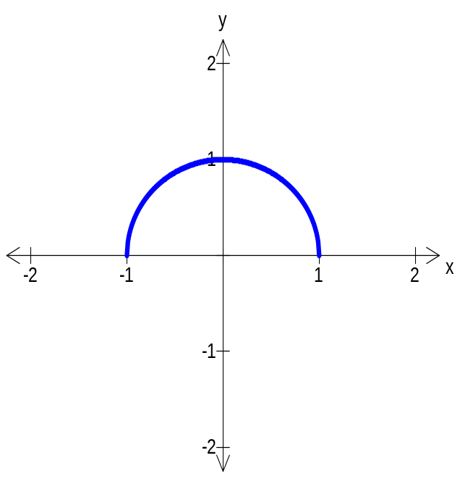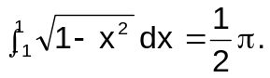 (2 marks)

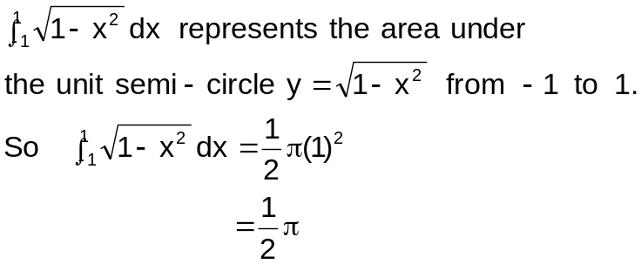

States that the integral represents the area under a semi-circle

States the radius

(b) A circular disc with equation (x – 3)² + y² = 1 is rotated about the y-axis. The solid obtained is a torus (a donut shaped solid).
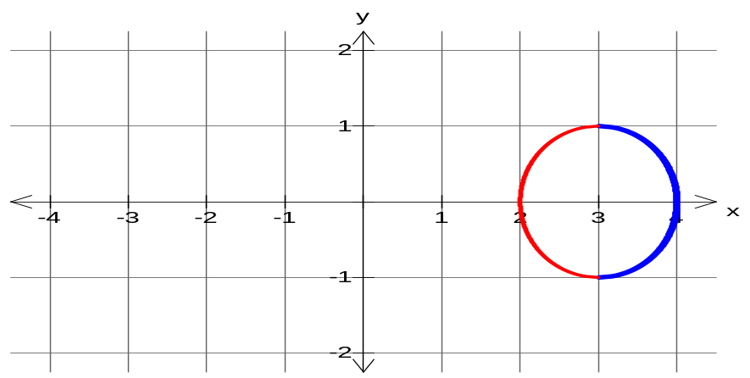 Find, by integration, the exact volume of the solid. (7 marks)

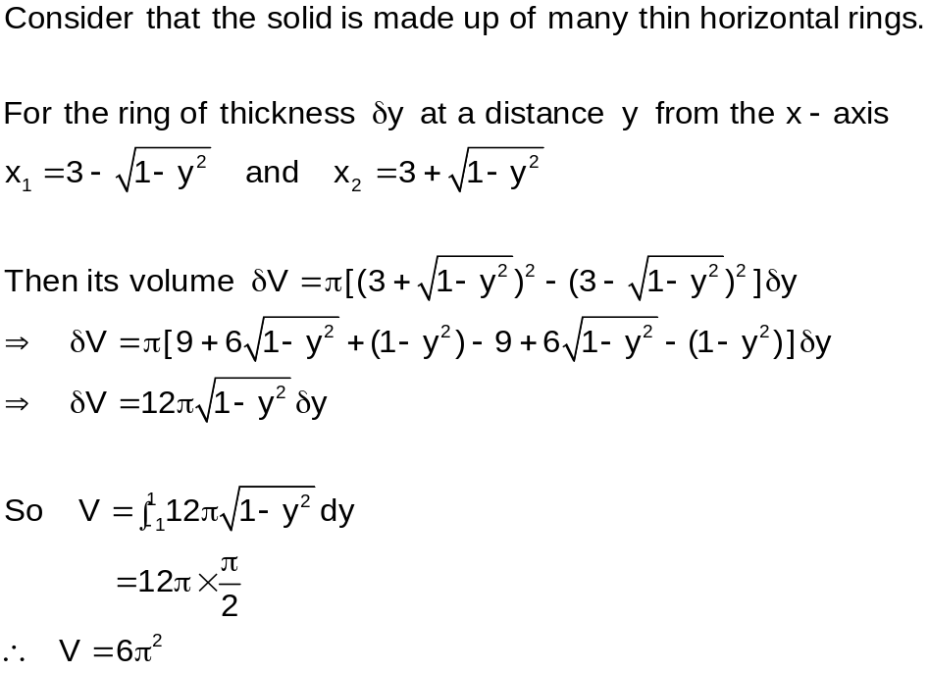

Considers that the solid is made of many thin horizontal rings

Determines x₁

Determines x₂

Gives δV in terms of x₁ and x₂ (or y)

Simplifies δV

Writes the integral for V

States the answer

OR

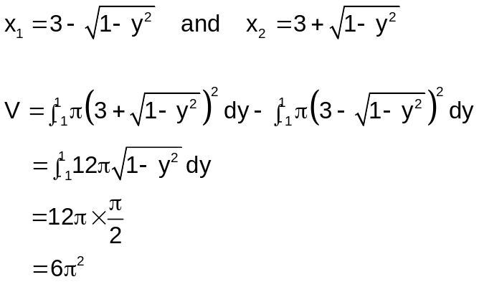
Determines x₁

Determines x₂

States formula for Volume of revolution about y-axis

Writes the volume as the difference of two integrals

Determines the correct bounds

Integrates for V

States answer exactly

Question 20 (6 marks)

Consider a real coefficient polynomial P(z) = z³ – 4z² + cz + d where c and d are unknowns.

(a) Given that z = u (≠ 0) is a root of the equation z³ – 4z² + cz + d = 0, determine one
solution of the equation dz³ + cz² – 4z + 1 = 0 in terms of u. (3 marks)
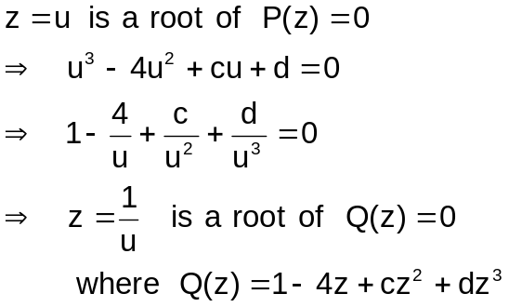

Sets up the equation

Divides the equation by u³

States the answer

(b) Given that z = 1 + i is a root of the equation z³ – 4z² + cz + d = 0, determine the values of c and d. (3 marks)
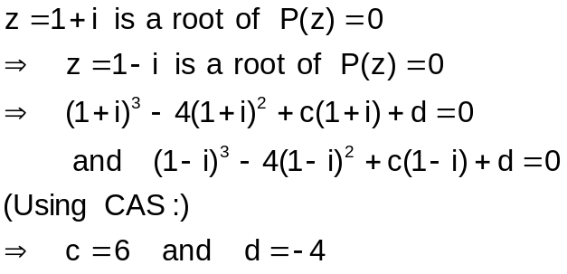
Writes z = 1 – i as another root

Sets up two equations

States the answers

Question 21 (7 marks)

The end points of a movable rod AB of length 1 metre have coordinates (x, 0) and
(0, y). The position of the end point A on the x-axis is
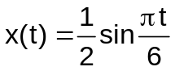

where t is the time in seconds.

(a) Determine the period of point B. (2 marks)
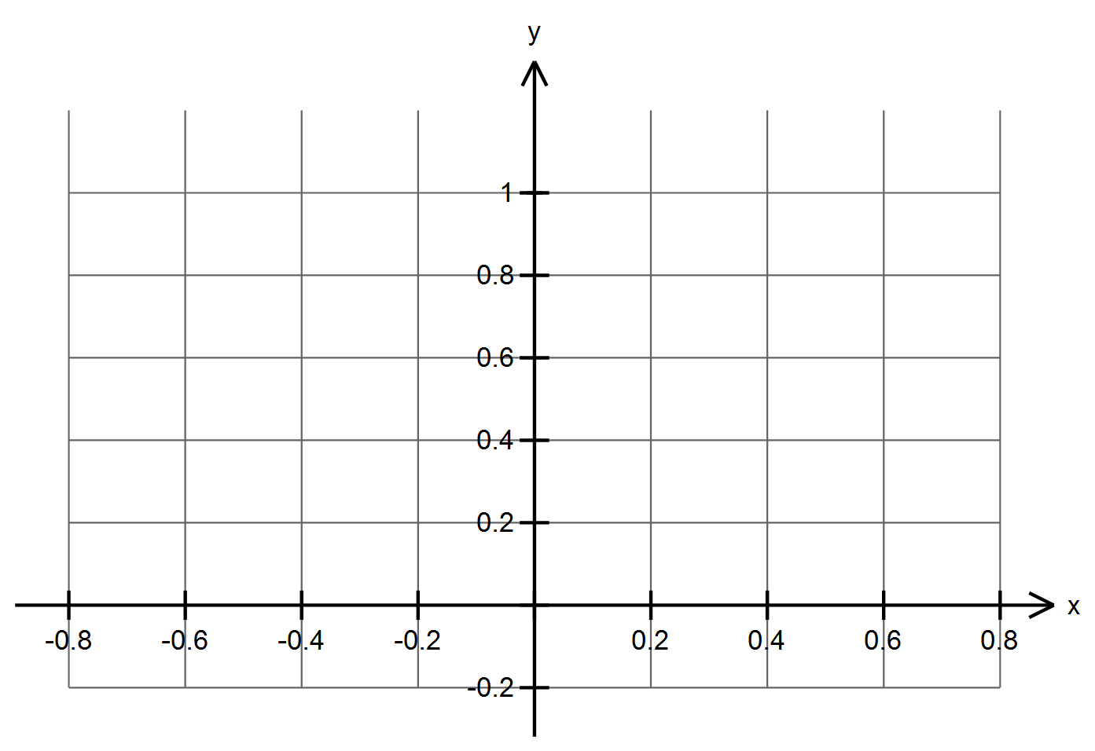
A
B
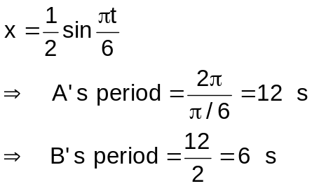

Determines A's period

Halves A's period to get B's period

(b) Determine the maximum speed of B and the first time it happens. (5 marks)

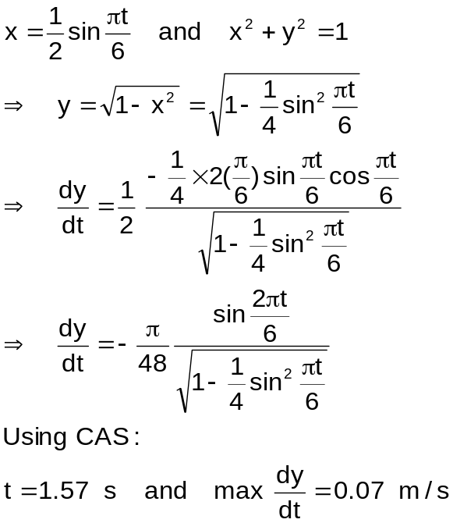

Sets up the equation x² + y² = 1

Writes y in terms of t

Expresses dy/dt in terms of t

States the answer for t

States the answer for dy/dt

Additional working space

Question number(s): ________________

Additional working space

Question number(s): ________________

Additional working space

Question number(s): ________________

